Table of Contents

1. INTRODUCTION: 1

2. OBJECTIVES: 1

3. DATA SET: 2

4. STUDY AREA: 2

5. METHODOLOGY: 3

5.1 Normalization of Bands: 3

5.2 Advanced Vegetation Index: 4

5.3 Bare Soil Index (BI): 5

5.4 Vegetation Density (VD): 6

5.5 Shadow Index (SI): 7

5.6 Scaled Shadow Index (SSI): 8

5.7 Forest Canopy Density (FCD): 9

6. Results: 10

7. Conclusion: 10

8. REFERENCES 11

**List of Figures**

Figure 1: Study Area 4

Figure 2: Methodology 5

Figure 3: Advance Vegetation Index 6

Figure 4: Bare Soil Index 7

Figure 5: Vegetation Density 8

Figure 6: Shadow Index 9

Figure 7: Scaled Shadow Index 10

Figure 8: Forest Canopy Density 11

# OBJECTIVES:

**The main objective of this study is to mapping the Forest Canopy Density extracted by the Landsat 8 imagery using FCD model**.

# DATA SET:

Landsat 8 images consist of spectral bands with a spatial resolution of 30 meters for band 1 – 7 and 9. And the resolution for band 8 (panchromatic) is 15 meters and thermal band 10 -11 are collected at 100 meters. Band 2 (green), band 3 (blue), band 4 (red), band 5 (NIR) and band 6 (SWIR1) are used in this study.

|  |  |
| --- | --- |
| Band Used In Equations | LANDSAT 8 Bands Numbers |
| Band 1 (Blue) | Band 2 |
| Band 2 (Green) | Band 3 |
| Band 3 (Red) | Band 4 |
| Band 4 (NIR) | Band 5 |
| Band 5 (SWIR1) | Band 6 |

Table 1: Data Set

# STUDY AREA:

The study area comprises Mansehra. It is a city in northern Pakistan. One of the largest cities of the Khyber Pakhtunkhwa province. The town is situated at the southern end of the Pakhli Plain on the Bhut Stream, a tributary to the Siran River, at an elevation of 3,682 feet (1,122 metres) above sea level.

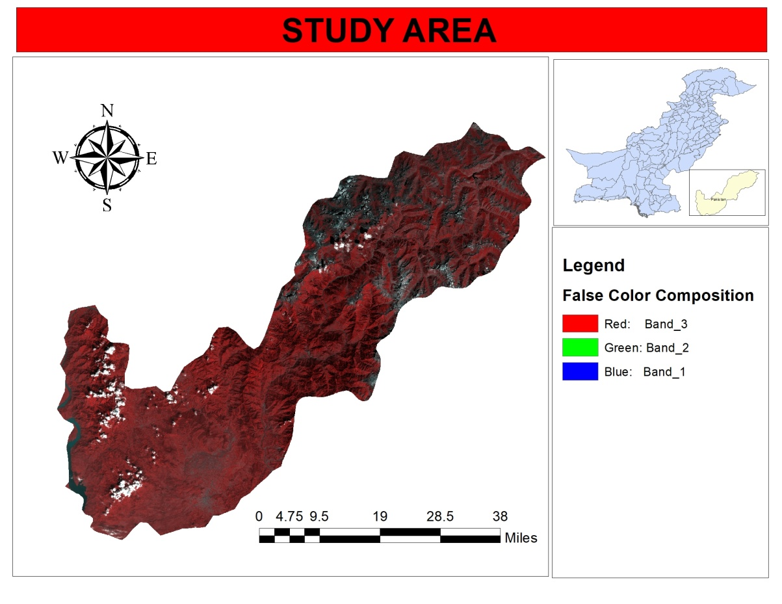

Figure : Study Area

# METHODOLOGY:

Figure 2 shows the methodology to extract Forest Canopy Density from satellite imagery proposed by Rikimaru [2].

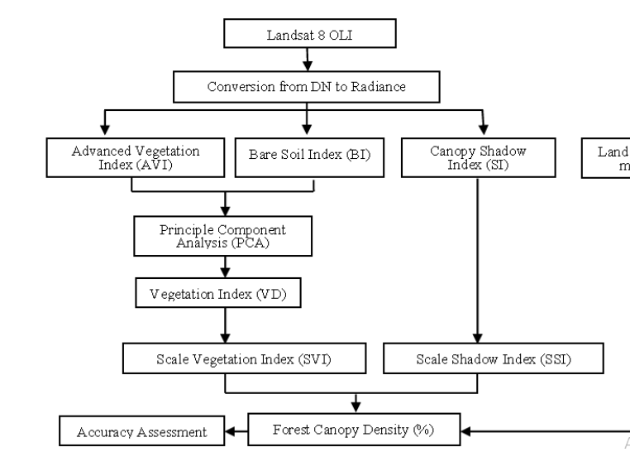

Figure : Methodology

## Normalization of Bands:

Landsat 8 blue, green, red, near-infrared and shortwave infrared 1 band are normalized by the following equation.

*Normalize Band = AX +B*

Where X, is the original data, A and B are calculated by following process.

*A = (Y1-Y2)/(X1-X2)   
B = -AX1+Y1*

Where, Y1and Y2 is the maximum and minimum value of each band respectively.

For X1 and X2,

*X1 = M-2S  
X2 = M+2S*

Where, “M” is the mean and “S” is the standard deviation of each band.

## Advanced Vegetation Index:

NDVI is unable to highlight subtle differences in canopy density. It has been found to improve by using power degree of the infrared response [3]. The index thus calculates as been termed as advanced vegetation index (AVI). AVI has been calculated using equation below:

AVI = 🡺 (A)

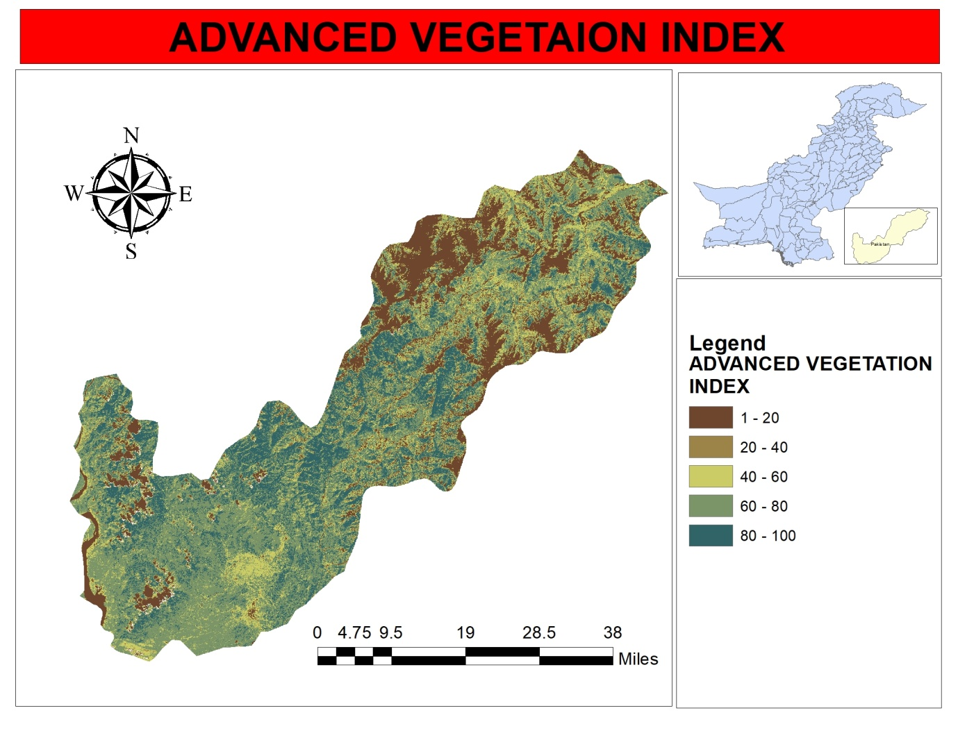

Figure : Advance Vegetation Index

## Bare Soil Index (BI):

The bare soil areas, fallow lands, vegetation with marked background response are enhanced using bare soil index (BI). BI is calculated using equation below:

BI = 🡺 (B)

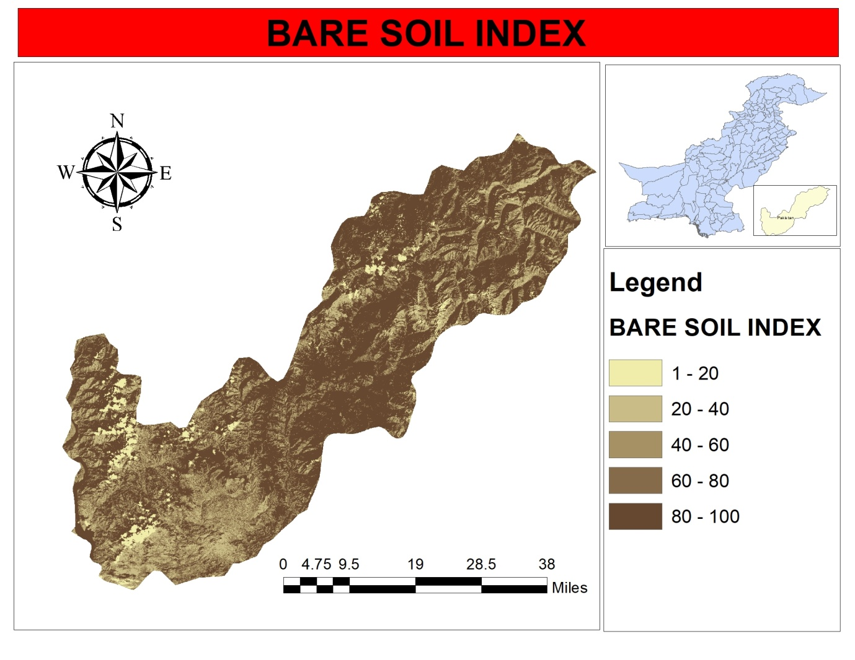

Figure : Bare Soil Index

## Vegetation Density (VD):

It is the procedure to synthesize AVI and BI using Principle Component Analysis (PCA) tool in ArcMAP. For achieving Vegetation Density, the AVI must have to rescale from 16 bits to 8 bits because AVI value is very high as compared to BI. The PCA tool uses the covariance between datasets. As the value of one dataset is extremely high and other is very low, PCA failed to find any covariance between dataset and gives the output which is not desirable. After that VD is rescale from zero percent point to hundred percent points.

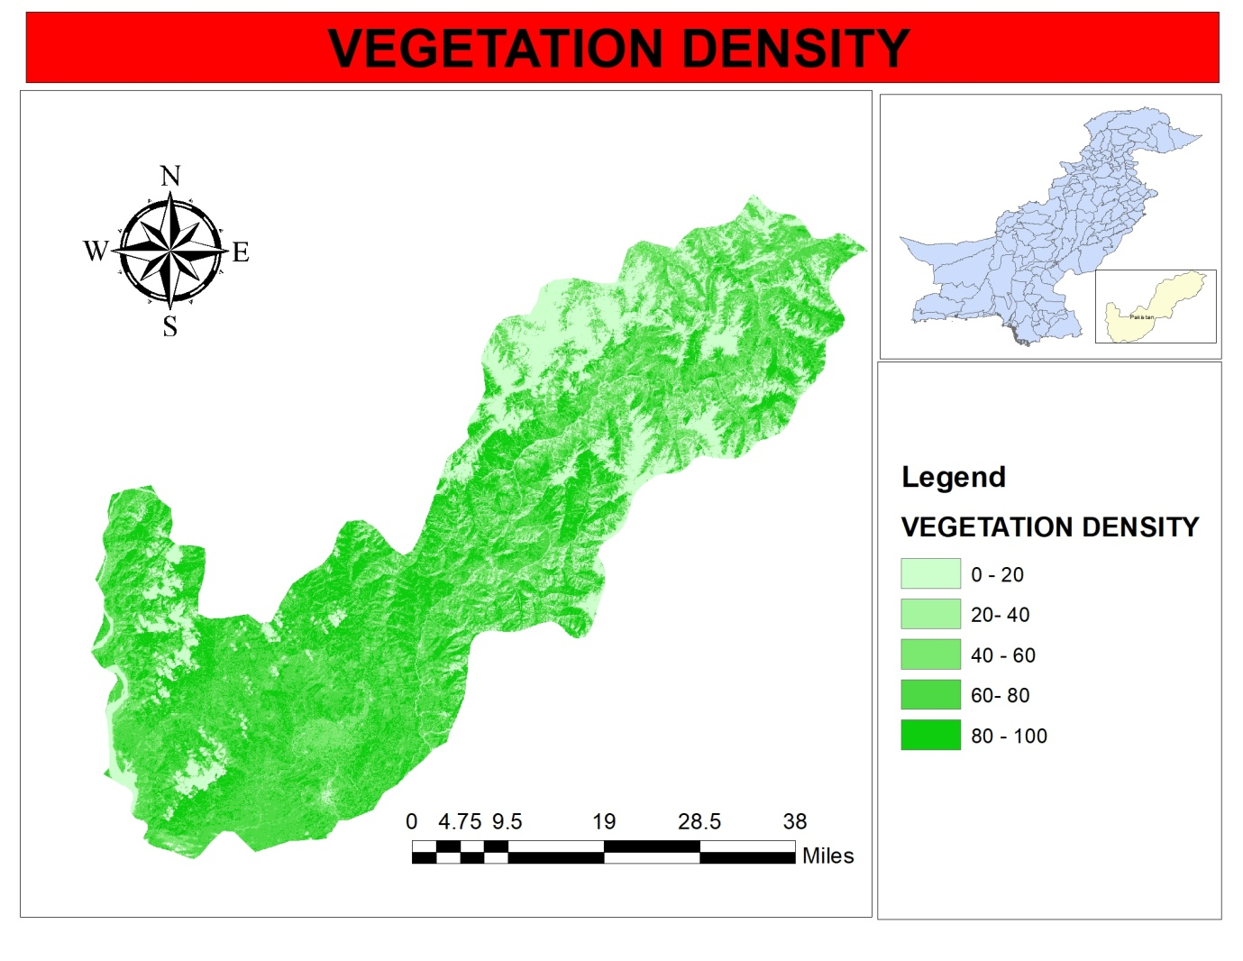

Figure : Vegetation Density

## Shadow Index (SI):

The crown arrangement in the forest stand leads to shadow pattern affecting the spectral response. The young even aged stand have low canopy Shadow Index (SI) compared to the mature natural forest stands. SI is calculated using visible bands of the spectrum.

SI = 🡺 (3)

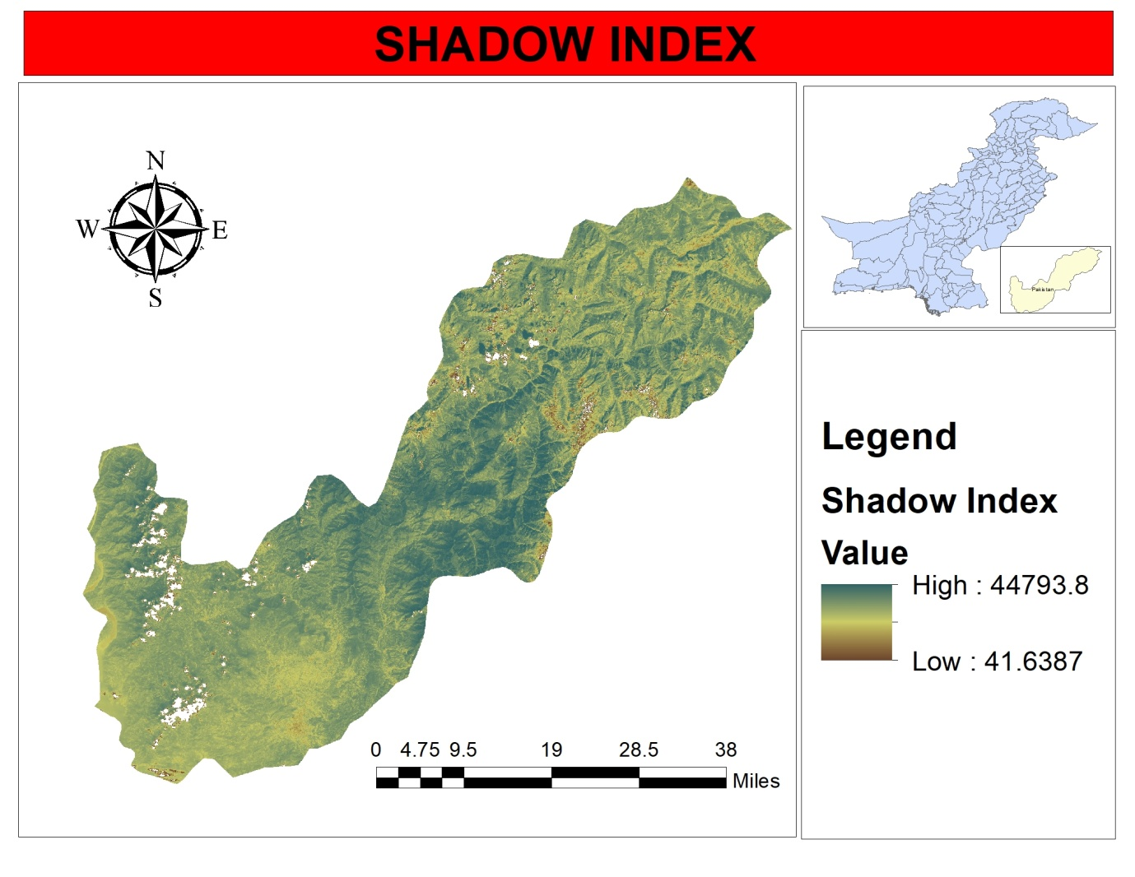

Figure : Shadow Index

## Scaled Shadow Index (SSI):

The Shadow Index SI is a relative value. Its normalized value can be utilized for calculation with other parameters. The SSI was developed in order to integrated AVI values and SI values. In areas where the SSI value is zero, this corresponds with forests that have the lowest shadow value (i.e. 0%). In areas where SSI value is 100, this corresponds with forests that have the highest possible shadow value (i.e. 100%). SSI is obtained by the linear transformation of SI [4] by using Rescale by function tool in ArcMAP.

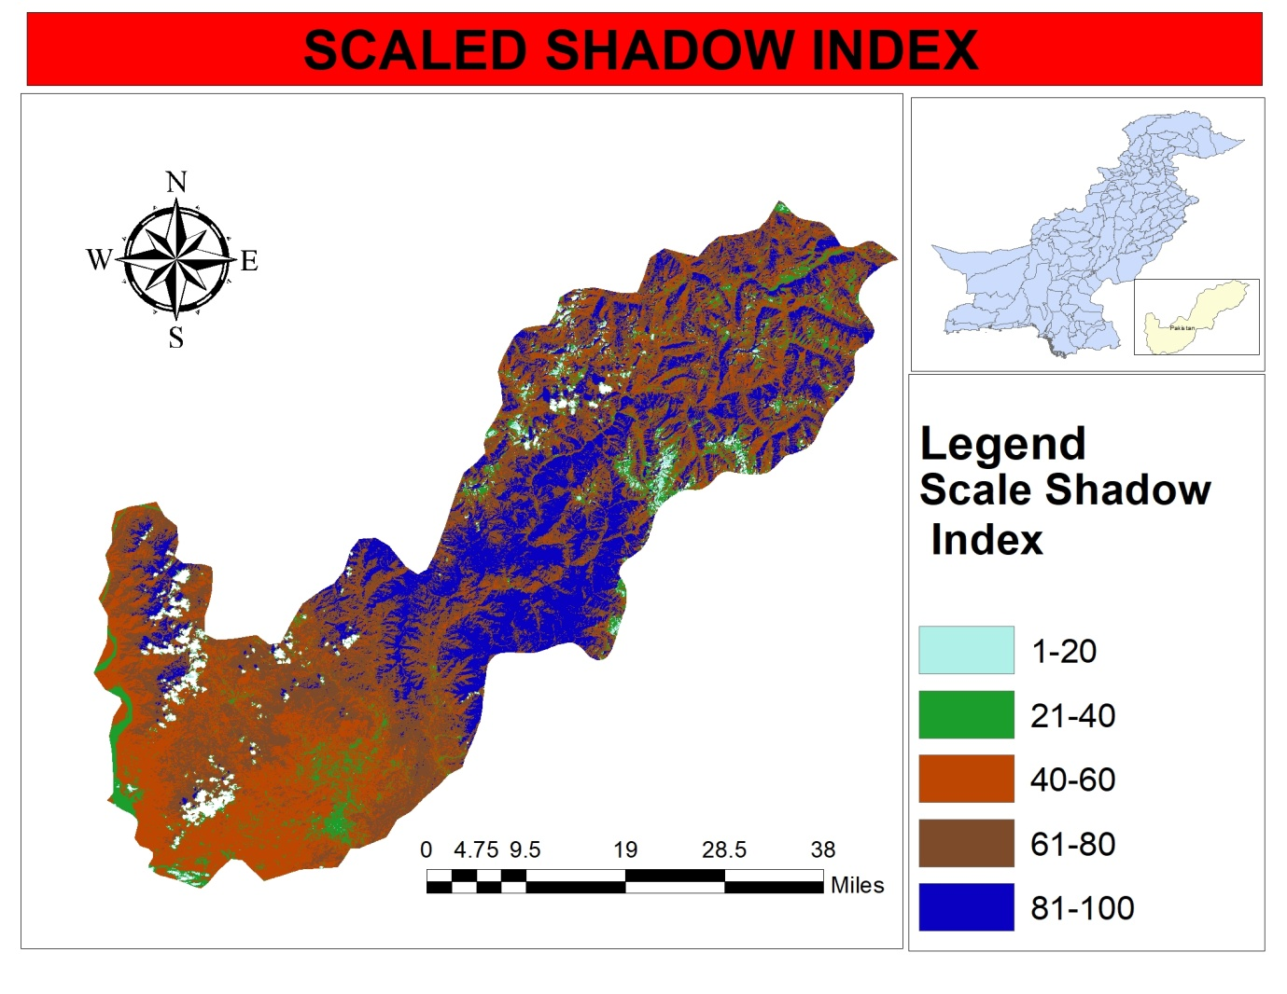

Figure : Scaled Shadow Index

## Forest Canopy Density (FCD):

FCD is one of the indices to identify the forest quality. Integration of VD and SSI means transformation for Forest Canopy Density value [5]. An equation is carried out to calculate FCD with scale from 0 to 100.

FCD = 🡺 (4)

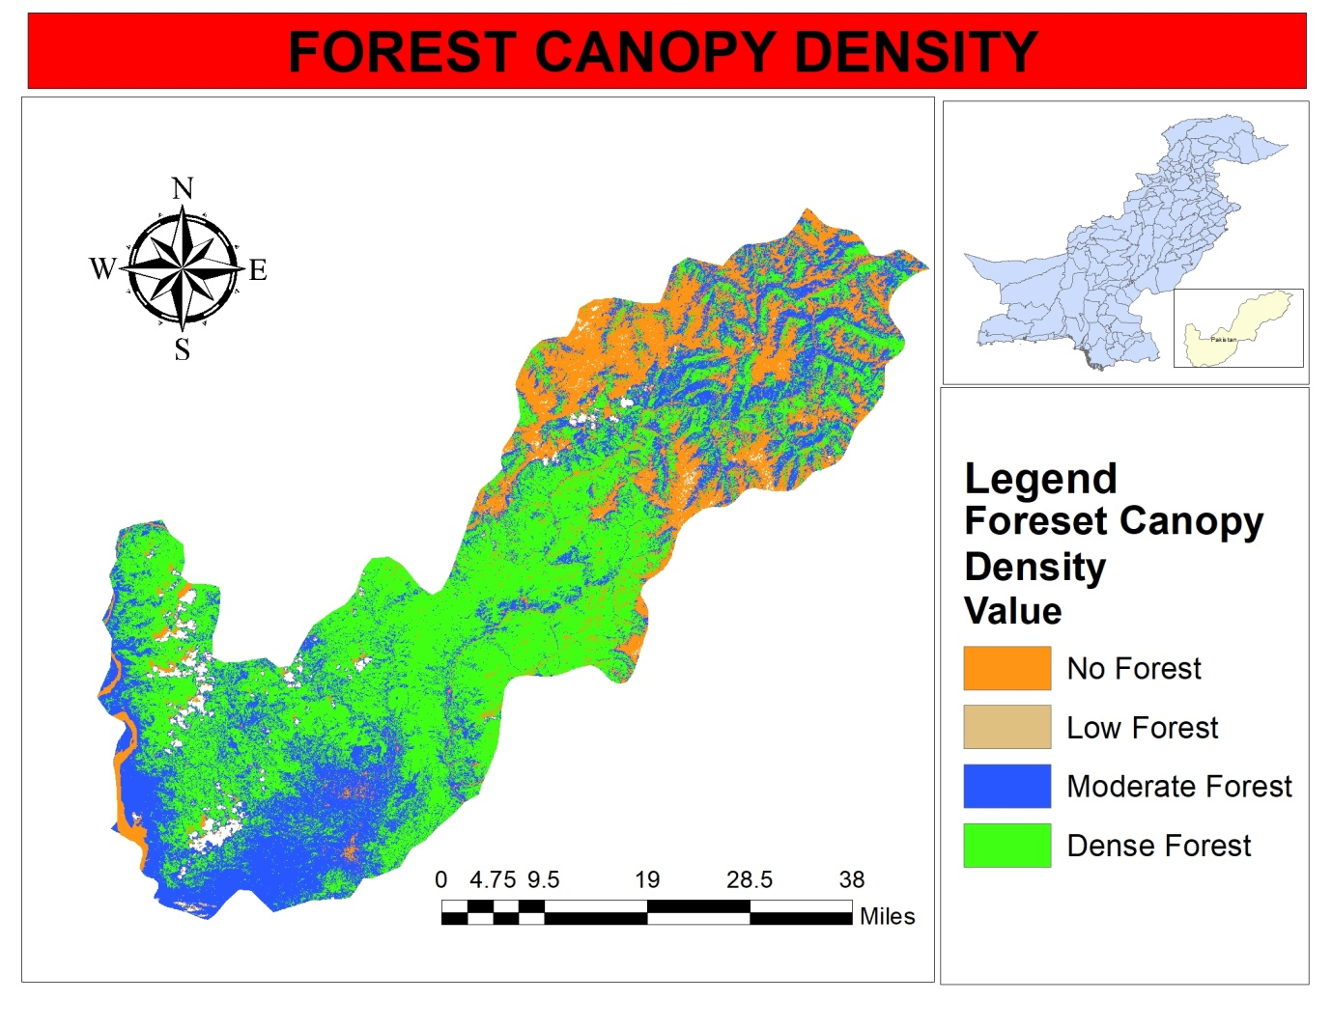

Figure : Forest Canopy Density

# Results:

In this study, forest density map have been prepared from the Landsat 8 imagery by using the equations of advanced Vegetation Index (AVI), Bare Soil Index (BI) and Shadow Index (SI) which has been calculated in ENVI.

The map described the distribution of forest resource in Mansehra through the FCD index. The majority of Mansehra is covered by moderate and dense forest.

# Conclusion:

Using GIS and remote sensing data, the achieved results have high reliability. Based on the physical properties and spectral reflection of the objects on the surface, the remote sensing images can provide much useful information in research. Landsat 8 satellite data was used to estimate the dense forest variations in a large scale in this study. The forest canopy density map expressed the forest situation of Mansehra through the level of canopy density.

However, this study can develop further by using many satellite images in the different period. This helps for assessing the changes of forest canopy density over time and space. This is one of the important criteria to evaluate the forest quality and contribute the information to forest management

# REFERENCES

[1] S. B. Jenning, N. D. Brown, and D. Shell, “Assessing forest canopies and understory illumination: Canopy closure, canopy cover and other mearsures,” Journal of Forest, vol. 1, pp. 59–73, 1999.

[2] A. Rikimaru, P. S. Roy, and S. Miyatake, “Tropical forest cover density mapping,” International Society for Tropical Ecology, pp. 39-47, 2002.

[3] W. Cuizhen and Q. Jiaguo, “Assessment of tropical forest degradation with canopy fractional cover from landsat ETM+ and IKONOS imagery,” Earth Interactions, vol. 9, no. 22, pp.1-17, 2005.

[4] J. Chudamani, D. L. Jan, K. S. Andrew, C. D. Iris, and O. Henk, “Remotely sensed estimation of forest canopy density: A comparison of the performance of four methods,” International Journal of Applied Earth Observation and Geoinformation, vol. 8, no. 2, pp. 84-95, 2006.

[5] S. Nandy, P. K. Joshi, and K. K. Das, “Forest canopy density stratification using biophysical modeling,” Journal of the Indian Society of Remote Sensing, pp. 291-297, 2003.